EXPERIMENT - 5
AIM: To create SQL views for department salary summary and employee hierarchy, test the updatability of views, and implement a recursive CTE to display reporting chains.

SOURCE CODE:
CREATE TABLE IF NOT EXISTS Department ( Dept_ID INT PRIMARY KEY,
Dept_Name VARCHAR(100) NOT NULL
);
CREATE TABLE IF NOT EXISTS Employee ( Emp_ID INT PRIMARY KEY,
Emp_Name VARCHAR(100) NOT NULL,
Job_Title VARCHAR(100), Salary DECIMAL(10, 2),
Dept_ID INT,
FOREIGN KEY (Dept_ID) REFERENCES Department(Dept_ID)
);
INSERT IGNORE INTO Department (Dept_ID, Dept_Name) VALUES (1, 'Engineering'),
(2, 'Sales'),
(3, 'Human Resources'),
(4, 'Finance'),
(5, 'Operations');
INSERT IGNORE INTO Employee (Emp_ID, Emp_Name, Job_Title, Salary, Dept_ID) VALUES (1, 'Ava Patel', 'Developer', 60000, 1),
(2, 'Liam Chen', 'Developer', 62000, 1),
(3, 'Mia Garcia', 'Analyst', 58000, 1),
(4, 'Noah Smith', 'Engineering Manager', 85000, 1),
(5, 'Olivia Jones', 'Developer', 61000, 1),
(6, 'Ethan Brown', 'Analyst', 56000, 1),

(7, 'Sophia Wilson', 'Sales Representative', 52000, 2),

(8, 'Lucas Davis', 'Sales Representative', 54000, 2),
(6, 'Amelia Miller', 'Sales Manager', 78000, 2),
(10, 'James Taylor', 'Sales Representative', 51000, 2),
(11, 'Isabella Anderson', 'Sales Representative', 53000, 2),
(12, 'Benjamin Thomas', 'Sales Representative', 55000, 2),
(13, 'Charlotte Moore', 'HR Specialist', 57000, 3),
(14, 'Elijah Martin', 'HR Specialist', 56000, 3),
(15, 'Harper Lee', 'Recruiter', 56000, 3),
(16, 'Daniel White', 'HR Manager', 80000, 3),
(17, 'Evelyn Harris', 'HR Specialist', 58000, 3),
(18, 'Henry Clark', 'Recruiter', 60000, 3),
(16, 'Abigail Lewis', 'Accountant', 63000, 4),
(20, 'Sebastian Walker', 'Accountant', 64000, 4),
(21, 'Emily Hall', 'Finance Manager', 88000, 4),
(22, 'Jack Allen', 'Accountant', 65000, 4),
(23, 'Ella Young', 'Financial Analyst', 67000, 4),
(24, 'Owen King', 'Financial Analyst', 66000, 4),
(25, 'Grace Wright', 'Operations Specialist', 55000, 5),
(26, 'Matthew Scott', 'Operations Specialist', 56000, 5),
(27, 'Chloe Green', 'Operations Manager', 82000, 5),
(28, 'Wyatt Baker', 'Operations Specialist', 57000, 5),
(26, 'Lily Adams', 'Coordinator', 52000, 5),
(30, 'Gabriel Nelson', 'Coordinator', 54000, 5); CREATE VIEW Department_Salary_Summary AS SELECT
D.Dept_ID, D.Dept_Name,

COUNT(E.Emp_ID) AS Total_Employees, AVG(E.Salary) AS Average_Salary,

MAX(E.Salary) AS Maximum_Salary, MIN(E.Salary) AS Minimum_Salary
FROM Department D LEFT JOIN Employee E
ON D.Dept_ID = E.Dept_ID
GROUP BY D.Dept_ID, D.Dept_Name; SELECT *
FROM Department_Salary_Summary; ALTER TABLE Employee
ADD Manager_ID INT NULL; ALTER TABLE Employee
ADD CONSTRAINT FK_Employee_Manager FOREIGN KEY (Manager_ID) REFERENCES Employee(Emp_ID); UPDATE Employee
SET Manager_ID = 4
WHERE Emp_ID IN (1, 2, 3, 5, 6);
UPDATE Employee SET Manager_ID = 6
WHERE Emp_ID IN (7, 8, 10, 11, 12);
UPDATE Employee SET Manager_ID = 16
WHERE Emp_ID IN (13, 14, 15, 17, 18);
UPDATE Employee SET Manager_ID = 21

WHERE Emp_ID IN (16, 20, 22, 23, 24);
UPDATE Employee SET Manager_ID = 27
WHERE Emp_ID IN (25, 26, 28, 26, 30);

CREATE VIEW Employee_Hierarchy AS SELECT
E.Emp_ID, E.Emp_Name, E.Job_Title, E.Salary, E.Manager_ID,
M.Emp_Name AS Manager_Name FROM Employee E
LEFT JOIN Employee M
ON E.Manager_ID = M.Emp_ID; SELECT *
FROM Employee_Hierarchy; UPDATE Employee
SET Salary = 60000 WHERE Emp_ID = 1; SELECT
Emp_ID, Emp_Name, Salary
FROM Employee WHERE Emp_ID = 1;
WITH RECURSIVE Employee_Chain AS

(
SELECT
Emp_ID, Emp_Name, Manager_ID, 1 AS Level

FROM Employee
WHERE Manager_ID IS NULL UNION ALL
SELECT
E.Emp_ID, E.Emp_Name, E.Manager_ID, EC.Level + 1
FROM Employee E
INNER JOIN Employee_Chain EC ON E.Manager_ID = EC.Emp_ID
)
SELECT
Emp_ID, Emp_Name, Manager_ID, Level
FROM Employee_Chain ORDER BY Level, Emp_ID;

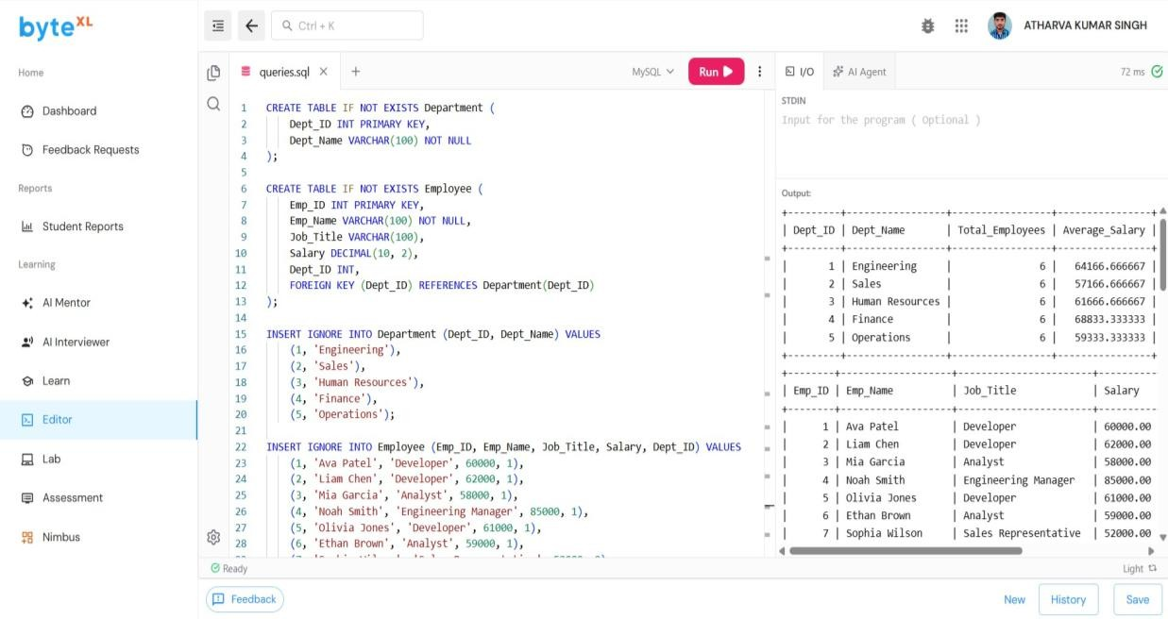

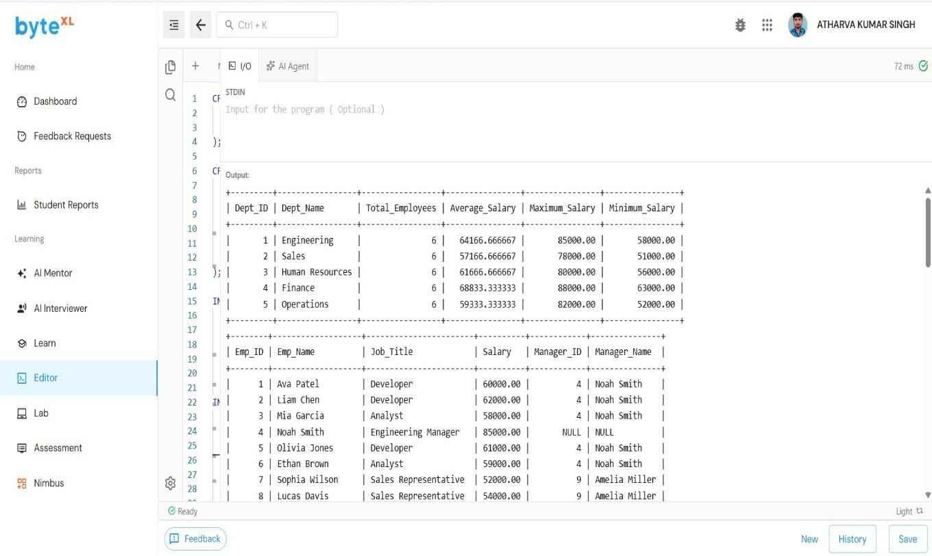
OUTPUT –

